Dock Pane
Pluggable widget for Mendix Studio Pro 10.24.17
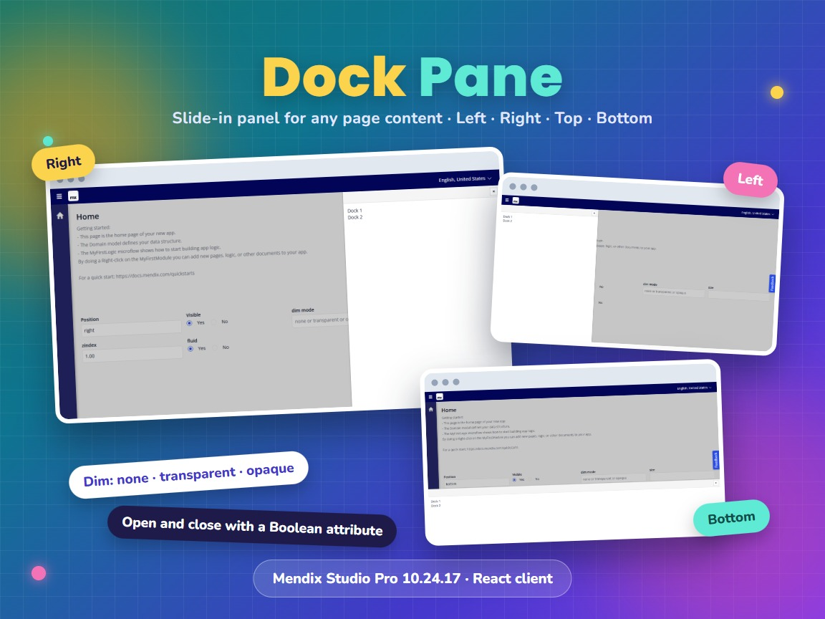
Item | Value
Widget version | 1.1.0
Studio Pro version | 10.24.17 (tested on 10.24.17.102810)
Widget ID | mendix.dockpane.DockPane
Widget package | mendix.DockPane.mpk (about 77 KB)
Platform | Web, React client (offline capable)
Dock library | react-dock 0.8.0
Build tooling | @mendix/pluggable-widgets-tools 10.16.0
Source and downloads | github.com/bharathidas/DockPane

Contents

1. Overview
Dock Pane shows page content in a panel that slides in from the left, right, top or bottom of the browser window. The panel lies over the page, so it does not change the page layout. It can dim the rest of the page while it is open.
You place any widgets in the dock pane: text, forms, lists, filters or buttons. A Boolean attribute opens and closes it, so a button, a microflow or a nanoflow can control it. The position, size, dim mode and z-index also come from attributes and can change at runtime.
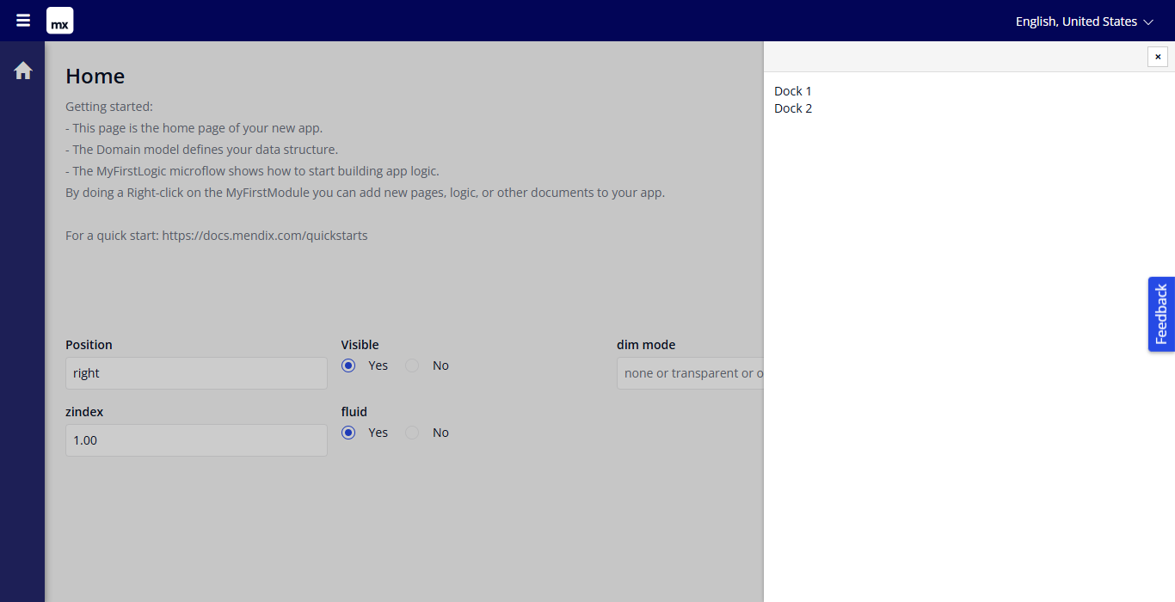
Figure 1. Dock pane on the right with the opaque dim mode

Typical uses
- A details or edit panel next to a list
- A filter panel that slides in over a dashboard
- A help or notification panel
- A settings panel or a shopping cart that opens from the side
- A message bar at the top or bottom of the window

2. What is new in version 1.1.0
- Rebuilt for Mendix Studio Pro 10.24.17 with @mendix/pluggable-widgets-tools 10.16.0, as a production build. The package is about 77 KB; version 1.0.0 was about 129 KB.
- Dim mode none works. In 1.0.0 it was treated as opaque.
- The close button and a click on the opaque dim area set the visibility attribute to false. Setting the attribute to true opens the dock pane again. In 1.0.0 the attribute stayed true, so the dock pane could not be reopened.
- The zIndex attribute is applied. When it is empty, no z-index is set, as in 1.0.0.
- Without a visibility attribute the dock pane is visible. In 1.0.0 it stayed hidden.
- Position and dim mode ignore case and spaces. An empty or zero size uses the default 0.35.
- The class and style from the Appearance tab are applied. The inline styles are now CSS classes, so a theme can override them.
- The close button has the label "Close" for screen readers.
- Studio Pro design mode shows a box with a drop zone for the content, instead of the real dock pane.
- Clearer property descriptions. The property keys are unchanged, so existing pages keep their settings.
Version 1.1.0 was tested in a Mendix 10.24.17 app: open and close, reopening, click on the dim area, the four positions, the three dim modes, fluid and pixel size, and z-index. The screenshots in this document are from that test.

3. Requirements
- Mendix Studio Pro 10.24.17 or a later 10.24 version.
- A web profile. The widget is not available for native mobile.
- No other modules or libraries are needed.

4. Installation

4.1 Install the widget
- Download mendix.DockPane.mpk from the Mendix Marketplace or from the GitHub release Version1.1.0.
- Copy the file into the widgets folder of your app. To find the folder, use App > Show App Directory in Explorer in Studio Pro.
- In Studio Pro, choose App > Synchronize App Directory (F4).
- The widget appears in the Toolbox as Dock Pane.

4.2 Upgrade from version 1.0.0
- Replace mendix.DockPane.mpk in the widgets folder with the 1.1.0 file.
- Synchronize the app directory (F4).
- Studio Pro reports that the widget definition has changed. Right-click the error and choose Update all widgets. Your settings are kept.
- If the running app still shows the old widget, stop it, choose App > Clean Deployment Directory, and run it again.
Check after upgrading: the visibility attribute now becomes false when the user closes the dock pane, and dim mode none no longer dims the page. If your logic relied on the old behaviour, adjust it.

5. Configuration

5.1 Prepare the domain model
Add the attributes you need to an entity, persistable or non-persistable. Only the visibility attribute is needed in most cases; every other setting has a default.
Attribute (example) | Type | Example value
Visible | Boolean | true
Position | String | right
DimMode | String | opaque
Size | Decimal or Integer | 0.35
ZIndex | Integer or Decimal | 1
Fluid | Boolean | true

5.2 Place the widget on a page
- Add a data view with the entity as context. The widget needs a context object.
- Drag Dock Pane from the Toolbox into the data view. Its place in the page does not matter, because the dock pane is fixed to a side of the window.
- Drop the content of the dock pane into the widget.
- Double-click the widget and select the attribute for is dock pane visible.
- Select attributes for the other properties you need.

5.3 Open and close
To open the dock pane, set the visibility attribute to true, for example with a button that calls a nanoflow with a Change object action. The user closes it with the × button, or with a click on the dimmed page when the dim mode is opaque. Both set the attribute to false.
Change object $Panel
Visible = true
Tip: with the dim mode opaque or transparent the dimmed page cannot be used, or only clicked through. Put the button that opens the dock pane on the page and the button that closes it inside the dock pane, or rely on the × button.

6. Property reference
All properties except the content and the action are attributes of the context object. The text in brackets is the behaviour when no attribute is selected or the attribute is empty.
Property | Type | Description (when empty)
Position of the dock pane | String attribute | left, right, top or bottom. Case and spaces are ignored. (left)
is dock pane visible | Boolean attribute | True shows the dock pane. The close button and a click on the opaque dim area set it to false. (No attribute: visible. Empty attribute: hidden.)
Dim Mode | String attribute | none, transparent or opaque. See chapter 8. (opaque)
size | Integer or Decimal attribute | Fluid true: fraction of the window, for example 0.35. Fluid false: pixels, for example 400. (0.35; also used for 0 and negative values)
zIndex | Integer or Decimal attribute | CSS z-index, a whole number of 1 or more. (No z-index is set.)
Fluid | Boolean attribute | True: the size is a fraction of the window and follows window resizing. (true)
Content | Widgets | The content of the dock pane.
On click action | Action | Runs when the dock pane or the dim area is clicked, also when a widget inside it is clicked. The × button does not run it.

7. Positions
Left and right dock panes take the full height of the window; top and bottom dock panes take the full width. The size is the width for left and right, and the height for top and bottom.
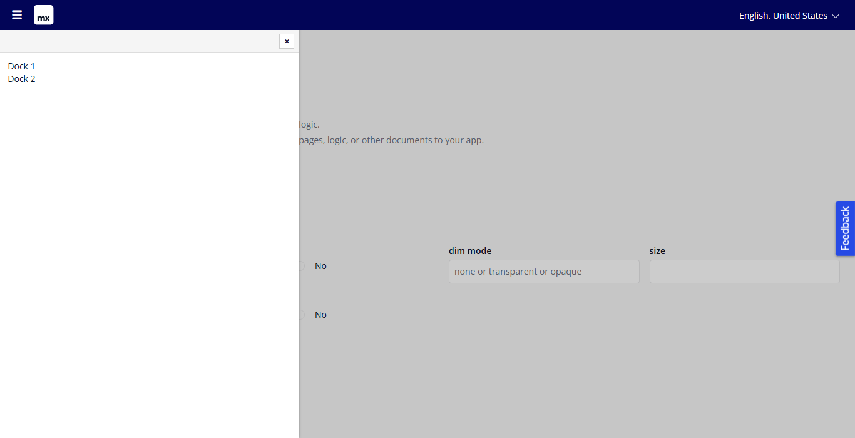
Figure 2. Position left
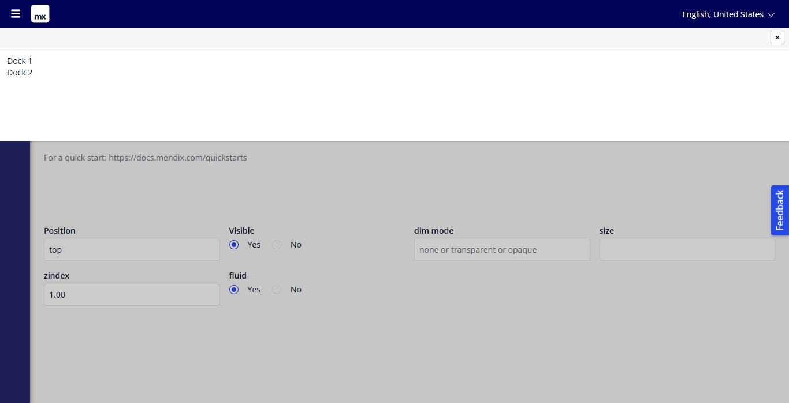
Figure 3. Position top
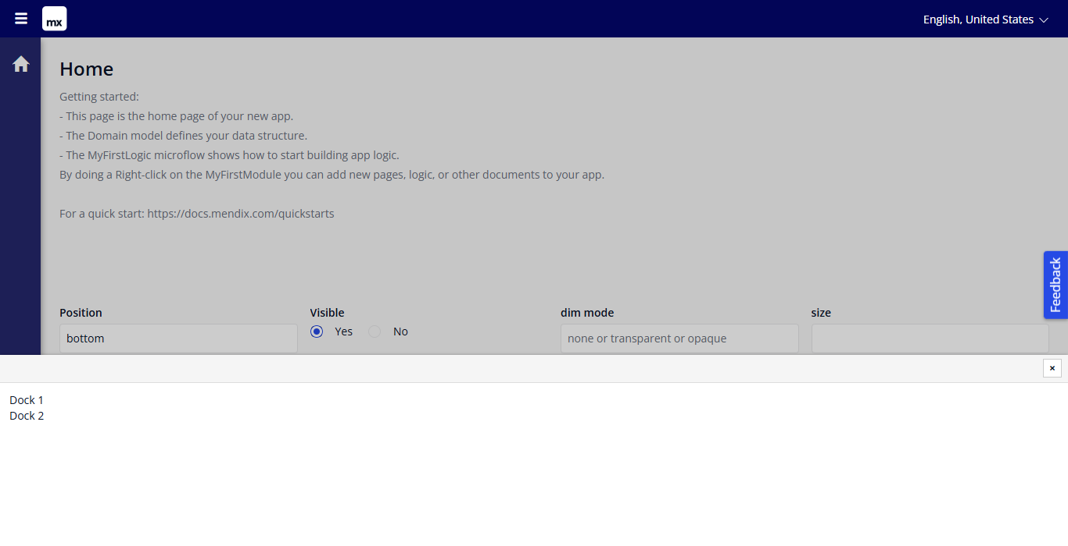
Figure 4. Position bottom

8. Dim modes
Dim Mode | Page behind the dock pane | Click on the page
opaque (default) | Dimmed | Closes the dock pane. The page itself does not receive the click.
transparent | Dimmed | Goes through to the page. The dock pane stays open.
none | Not dimmed | Goes to the page. The dock pane stays open.

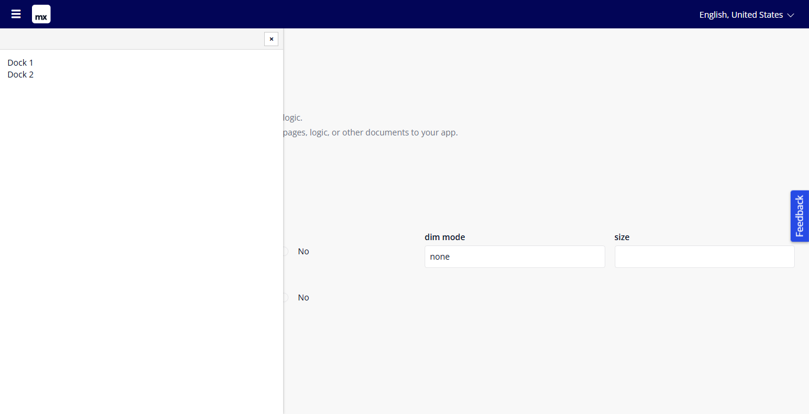
Figure 5. Dim mode none: the page is not dimmed and can be used
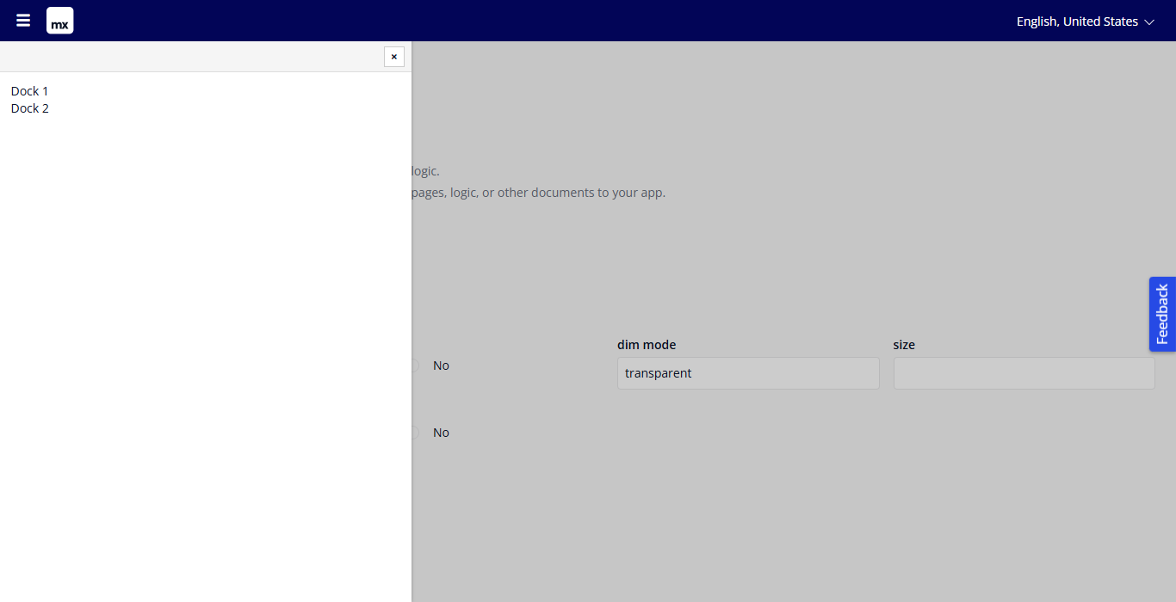
Figure 6. Dim mode transparent: the page is dimmed, clicks go through

9. Size, fluid and z-index
- Fluid true (default): the size is a fraction of the window. 0.35 is 35% of the window width (left, right) or height (top, bottom). The dock pane follows the window when it is resized.
- Fluid false: the size is in pixels, for example 300.
- With Fluid true, use a value between 0 and 1. A value such as 300 would make the dock pane 300 times the window size.
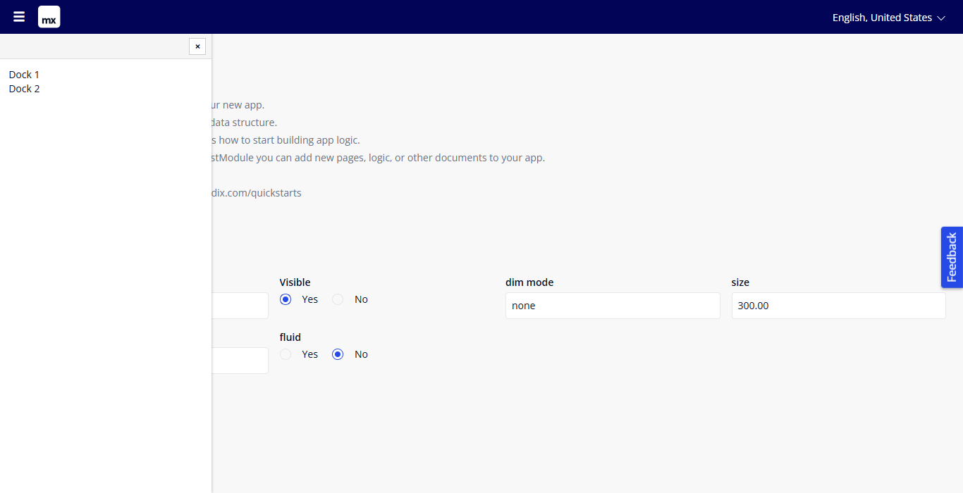
Figure 7. Fluid false with size 300: a dock pane of 300 pixels
- zIndex decides what lies on top. Without a z-index, and with a low value such as 1, the Atlas top bar stays above the dock pane; the dock pane has 48 pixels of empty space at the top for that reason (not for position bottom). Use a higher value to lay the dock pane over the top bar.

10. Styling
The widget renders these elements. The class and style from the Appearance tab are applied to the outer element.
<div class="widget-dockpanel your-class">
... react-dock elements (dim area, resize handle) ...
<div class="widget-dockpanel-body widget-dockpanel-right">
<div class="widget-dockpanel-header"><button class="widget-dockpanel-close">×</button></div>
<div class="widget-dockpanel-content"> your content </div>
</div>
</div>
Examples for your theme:
/* No empty space at the top, for a dock pane that lies over the top bar */
.widget-dockpanel-body { padding-top: 0; }

/* Coloured header and no padding around the content */
.widget-dockpanel-header { background-color: #0a1325; border-bottom: none; }
.widget-dockpanel-content { padding: 0; }
The second class on the body is the position: widget-dockpanel-left, -right, -top or -bottom.

11. Known behaviour and limitations
- The settings are attributes. Static values cannot be typed in the widget properties; use attribute default values or set the values in a microflow or nanoflow.
- The widget needs a context object, so it must be inside a data view or list view.
- When the visibility attribute is read-only, the close button hides the dock pane but cannot change the attribute. The dock pane then opens again only after the attribute changes to false and back to true.
- The user cannot resize the dock pane by dragging its edge, because the size comes from the attribute.
- The On click action also runs for clicks on widgets inside the dock pane.
- The opening animation and its duration are fixed.
- Position and dim mode are String attributes. Enumeration attributes cannot be selected. An unknown value falls back to left and opaque.
- Web only; not available in native mobile apps.

12. Support and version history
Report issues, suggestions and feature requests on GitHub:
https://github.com/bharathidas/DockPane/issues
Source code and all releases:
https://github.com/bharathidas/DockPane
Widget | Studio Pro | GitHub release | Changes
1.1.0 | 10.24.17 | Version1.1.0 | Rebuilt for Studio Pro 10.24.17; dim mode none; closing writes the visibility attribute; z-index applied; class and style applied; CSS classes; design-mode preview.
1.0.0 | 10.24.6 | Version1.0.0 | First release.

